1. Solve the equation: 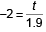
A. t = –3.9
B. t = 3.8
C. t = –3.8
D. t = –1.1

2. Determine the slope and the y-intercept of the line 7x + 3y = –8.
A. 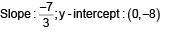
B. 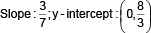
C. 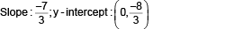
D. 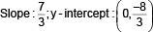

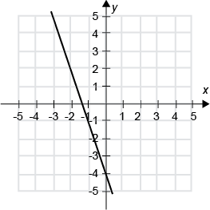
3. Write an equation of the given line in slope-intercept form.
A. y = –4x + 3
B. y = 3x – 4
C. y = –3x – 4
D. y = –4x – 3

4. A line contains the point (–3, –4) and is perpendicular to a line with a slope of . Write an equation of the line satisfying the given conditions. Write the answer in slope-intercept form.
A.
B.
C.
D.

5. Solve the inequality. Write the solution set in interval notation.
11 ≤ 6(n + 4) – 4n
A. [4,11]
B.
C.
D.

6.Solve the equation: 2(–3 – 3x) = 24
A. x = –5
B. x = 5
C. x = –7
D. x = 6

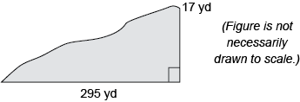
7. Find the slope of the hill.
A. 295
B.
C.
D.

8. Find the slope of the line determined by the equation 2x = y.
A. m = 2
B. m = –2
C. m = –3
D. m = 3

9. To ride certain amusement park rides, riders must be a least 44″ tall, but no more than 83″ tall. Let h represent the height of a prospective rider. Write an inequality that represents the allowable heights.
A. h ≤ 83 and h ≥ 44
B. h ≤ 44 and h ≥ 83
C. h ≤ 44 or h ≥ 83
D. h ≤ 83 or h ≥ 44

10. Which one of the following equations represents the y-axis?
A. x = 0
B. y = –1
C. y = 0
D. x = –1

11. Solve the absolute value equation.
|12 + 2x| = |x – 6|
A. {–18}
B. {–18, –6}
C. {–18, –2}
D. {}

12. Identify the inequality that matches the graph.
A. |x – 1| > 3
B. |x + 1| > 6
C. |x + 1| > 3
D. |x – 1| > 6

13. Given A = {–3,–26,10,30,–14,9} and B = {–9,6,10,–14}, list the elements of A∩B.
A. {10,–14}
B. {–3,–26,10,30,–14,9,–9,6}
C. {}
D. {10}

14. Graph the linear equation: 3y = –2x – 1
A.
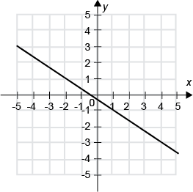
B.
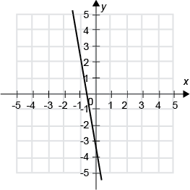
C.
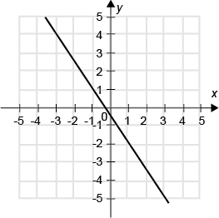
D.
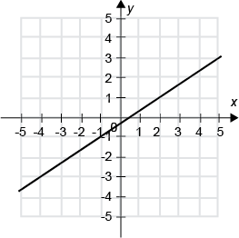

15. Solve the inequality. Write the answer in interval notation.
–2 < –2y + 19 < 10
A.
B.
C.
D.

16. Solve the equation: 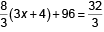
A. x = –10
B. x = 12
C. x = 8
D. x = –12

17. Use substitution to determine which value is the solution to 5x + 3 = 18.
A. x = 1
B. x = 9
C. x = 3
D. x = 2

18. Use substitution to determine which value is the solution to –9x – 8 = 19.
A. x = 4
B. x = –5
C. x = –3
D. x = –4

19. A tool rental store charges a flat fee of $9.50 to rent a chain saw, and $3.75 for each day, including the first. Write an equation that expresses the cost y of renting this saw if it's rented for x days.
A. y = 3.75(x + 9.50)
B. y = 3.75x – 9.50
C. y = 3.75x + 9.50
D. y = 9.50x + 3.75

20. Given that (–2, y) and (4, 6) are points on a line whose slope is , find y.
A. y = 14
B. y = 18
C. y = 10
D. y = 17

